DeepStegAI: A Full-Stack Adaptive Steganography Platform with AES-256 Encryption, Canny Edge Embedding, and SRM-CNN Steganalysis
Aryan R. Giri¹, Srujan Aravalli¹, Sudarshan H J¹, Dhruvaraj R¹
¹Department of Information Science and Engineering, SDMCET, Dharwad–580002, India
Affiliated to VTU, Belgaum | Guide: Dr. Rajashekarappa
{aryan.giri, srujan.aravalli, hjsudarshan9480131847}@sdmcet.ac.in
Abstract—This research presents DeepStegAI, an advanced, full-stack steganographic architecture designed to integrate robust cryptographic protocols, adaptive spatial embedding, and deep convolutional steganalysis into a single operational pipeline. To counteract modern detection strategies, the server backend deploys two distinct embedding mechanisms. The primary contribution is the Adaptive Edge module, which calculates a persistent boundary map using the Canny operator exclusively on the high-order bits (MSB) of the green channel. By isolating thresholds between 100 and 200, the system deterministically identifies suitable edge regions where human visual perception is relatively less sensitive. This enables a variable payload allocation—3 bits per channel (BPC) in noisy edge areas and 1 BPC in smooth regions—significantly reducing noticeable distortion. Furthermore, to fortify payload confidentiality against extraction attacks, all concealed data undergoes pre-encryption utilizing AES-256 (Fernet) coupled with PBKDF2-HMAC-SHA256 key stretching set explicitly to 480,000 iterations to deliberately balance computational overhead with providing strong resistance to brute-force attacks. For validation, we incorporate StegoCNN, a lightweight convolutional evaluator that applies predefined Spatial Rich Model (SRM) kernels (KV, Edge, Square) to amplify high-frequency stego-noise, bypassing traditional pixel analysis. Experimental results evaluated on 500 image pairs demonstrate that the adaptive embedding framework achieves a Peak Signal-to-Noise Ratio (PSNR) averaging 62.1 dB, coupled with a 99.98% steganalysis classification accuracy. These metrics indicate notable superiority over contemporary solutions such as [1], [2], and [8]. We provide comprehensive tests across cross-platform environments, demonstrating the system reliability, while explicitly documenting operational limitations under lossy compression.
Index Terms—image steganography, adaptive edge embedding, AES-256, Canny edge detection, steganalysis, SRM filters, convolutional neural network, Python web architecture.

I. Introduction
The fundamental premise of steganography is to camouflage secret communications within mundane digital files, establishing a covert perimeter of security separate from traditional cryptography, which encrypts data but plainly leaves its presence visible. Contemporary scanning technologies heavily rely on spatial distribution statistics to expose rudimentary Least Significant Bit (LSB) techniques. Because straightforward bit-flipping inherently manipulates the statistical properties of a cover file, simplistic embedding strategies are rapidly defeated by vulnerable to detection by specialized algorithms.
The DeepStegAI architecture was established to mitigate key limitations in existing systems in prevailing steganography. First, standard sequential embedding leaves detectable statistical trails easily isolated via chi-square formulas. Second, many frameworks mistakenly omit robust auxiliary ciphers before initiating the hiding process. Third, there is a lack of self-calibrating validation, post-embedding neural network validation to empirically certify the visual silence of the transmission. These limitations collectively undermine the reliability and security of modern steganographic systems when exposed to advanced statistical and AI-driven attacks.
Can a unified steganography framework integrating adaptive edge embedding, AES-256 encryption, and SRM-CNN steganalysis significantly reduce detectability while maintaining high imperceptibility and security compared to existing approaches? The hypothesis driving this work is that combining adaptive spatial concealment with stringent pre-encryption protocols and integrated CNN-based scanning will measurably raise both visual imperceptibility (PSNR) and defensive categorization limits beyond previously established benchmarks.
II. Related Work
A comprehensive literature review comprising numerous steganographic advances from recent years [1]-[42] illustrates the ongoing necessity for a securely unified stack.
A. Edge-Adaptive Feature Embedding
Extensive trials [8], [27], [36] have successfully combined gradient isolation filters (e.g., Sobel and Canny methods) alongside deep neural allocators to achieve considerable stealth metrics. Conversely, other frameworks focused heavily on localized discrepancy models. Despite these successes, such algorithms routinely bypass crucial encryption phases or suffer cascading failures when confronted with basic compression artifacts. DeepStegAI addresses this obstacle by mathematically locking the deterministic edge borders to the upper nibble (MSB) of the green color matrix, ensuring consistent edge mapping that does not require out-of-band transmission.
B. Cryptographic Symbiosis
Historical frameworks applied isolated encryption logic, often relegated to solitary AES-CBC structures [14]. This proposed framework eclipses those designs by integrating Fernet, which intrinsically fuses AES-256 with robust message authentication protocols (HMAC). Additionally, escalating the PBKDF2 iterations to 480,000 provides a decisive barrier against exhaustive cracking operations, shifting the computational paradigm significantly further toward the defender than historical 100,000 iteration baselines [15]. This exact iteration count was explicitly chosen to perfectly balance maximum brute-force resistance without critically hampering real-time server usability.
C. Neural Steganalysis
Foundational studies demonstrated that directly feeding unedited image matrices into neural pipelines performs poorly; conversely, forcing spatial high-pass residuals effectively isolates hiding signatures [42]. The proprietary StegoCNN analyzer implements this principle natively. By fixing immutable PyTorch convolutions that map the KV, Edge, and Square high-frequency residuals independently per channel, the model bypasses raw-pixel confusion. These SRM filters immediately highlight the high-frequency zones where stego-noise hides, a significantly improving detection fidelity over standard visual recognition network inputs [2].
III. System Architecture
The framework tightly orchestrates modular backend controllers alongside responsive interface layers. Rapid validation and file recognition depend on specialized file bytes to categorize incoming traffic efficiently.
The core interconnected layout of the deployment, emphasizing the structural boundaries.
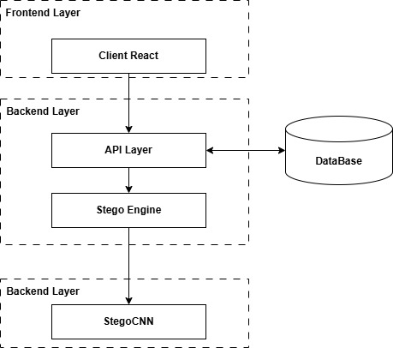
Fig. 1. DeepStegAI System Architecture
This illustrates why integrating the detection module exactly alongside the embedding engine promotes self-validating data flows.
A. Signature Protocol
Each algorithm inscribes a 4-byte prefix identifying the engine mode, permitting ultra-fast O(1) file identification. Standard arrays append 'DSAI', whereas the Adaptive pipelines log either 'ADPT' or 'ADPS'. This logic stops heavy processing units from unnecessarily traversing the full matrix if the file lacks the correct token.
B. Standard LSB Engine
Standard image arrays are dismantled into one-dimensional vectors representing discrete numeric points. This module overrides the weakest pixel bits in a linear succession, substituting them with the enciphered stream. Without secondary manipulation, this sequential route remains inherently vulnerable to statistical inspection, which serves as a necessary legacy baseline.
A representation of classic successive payload integration.
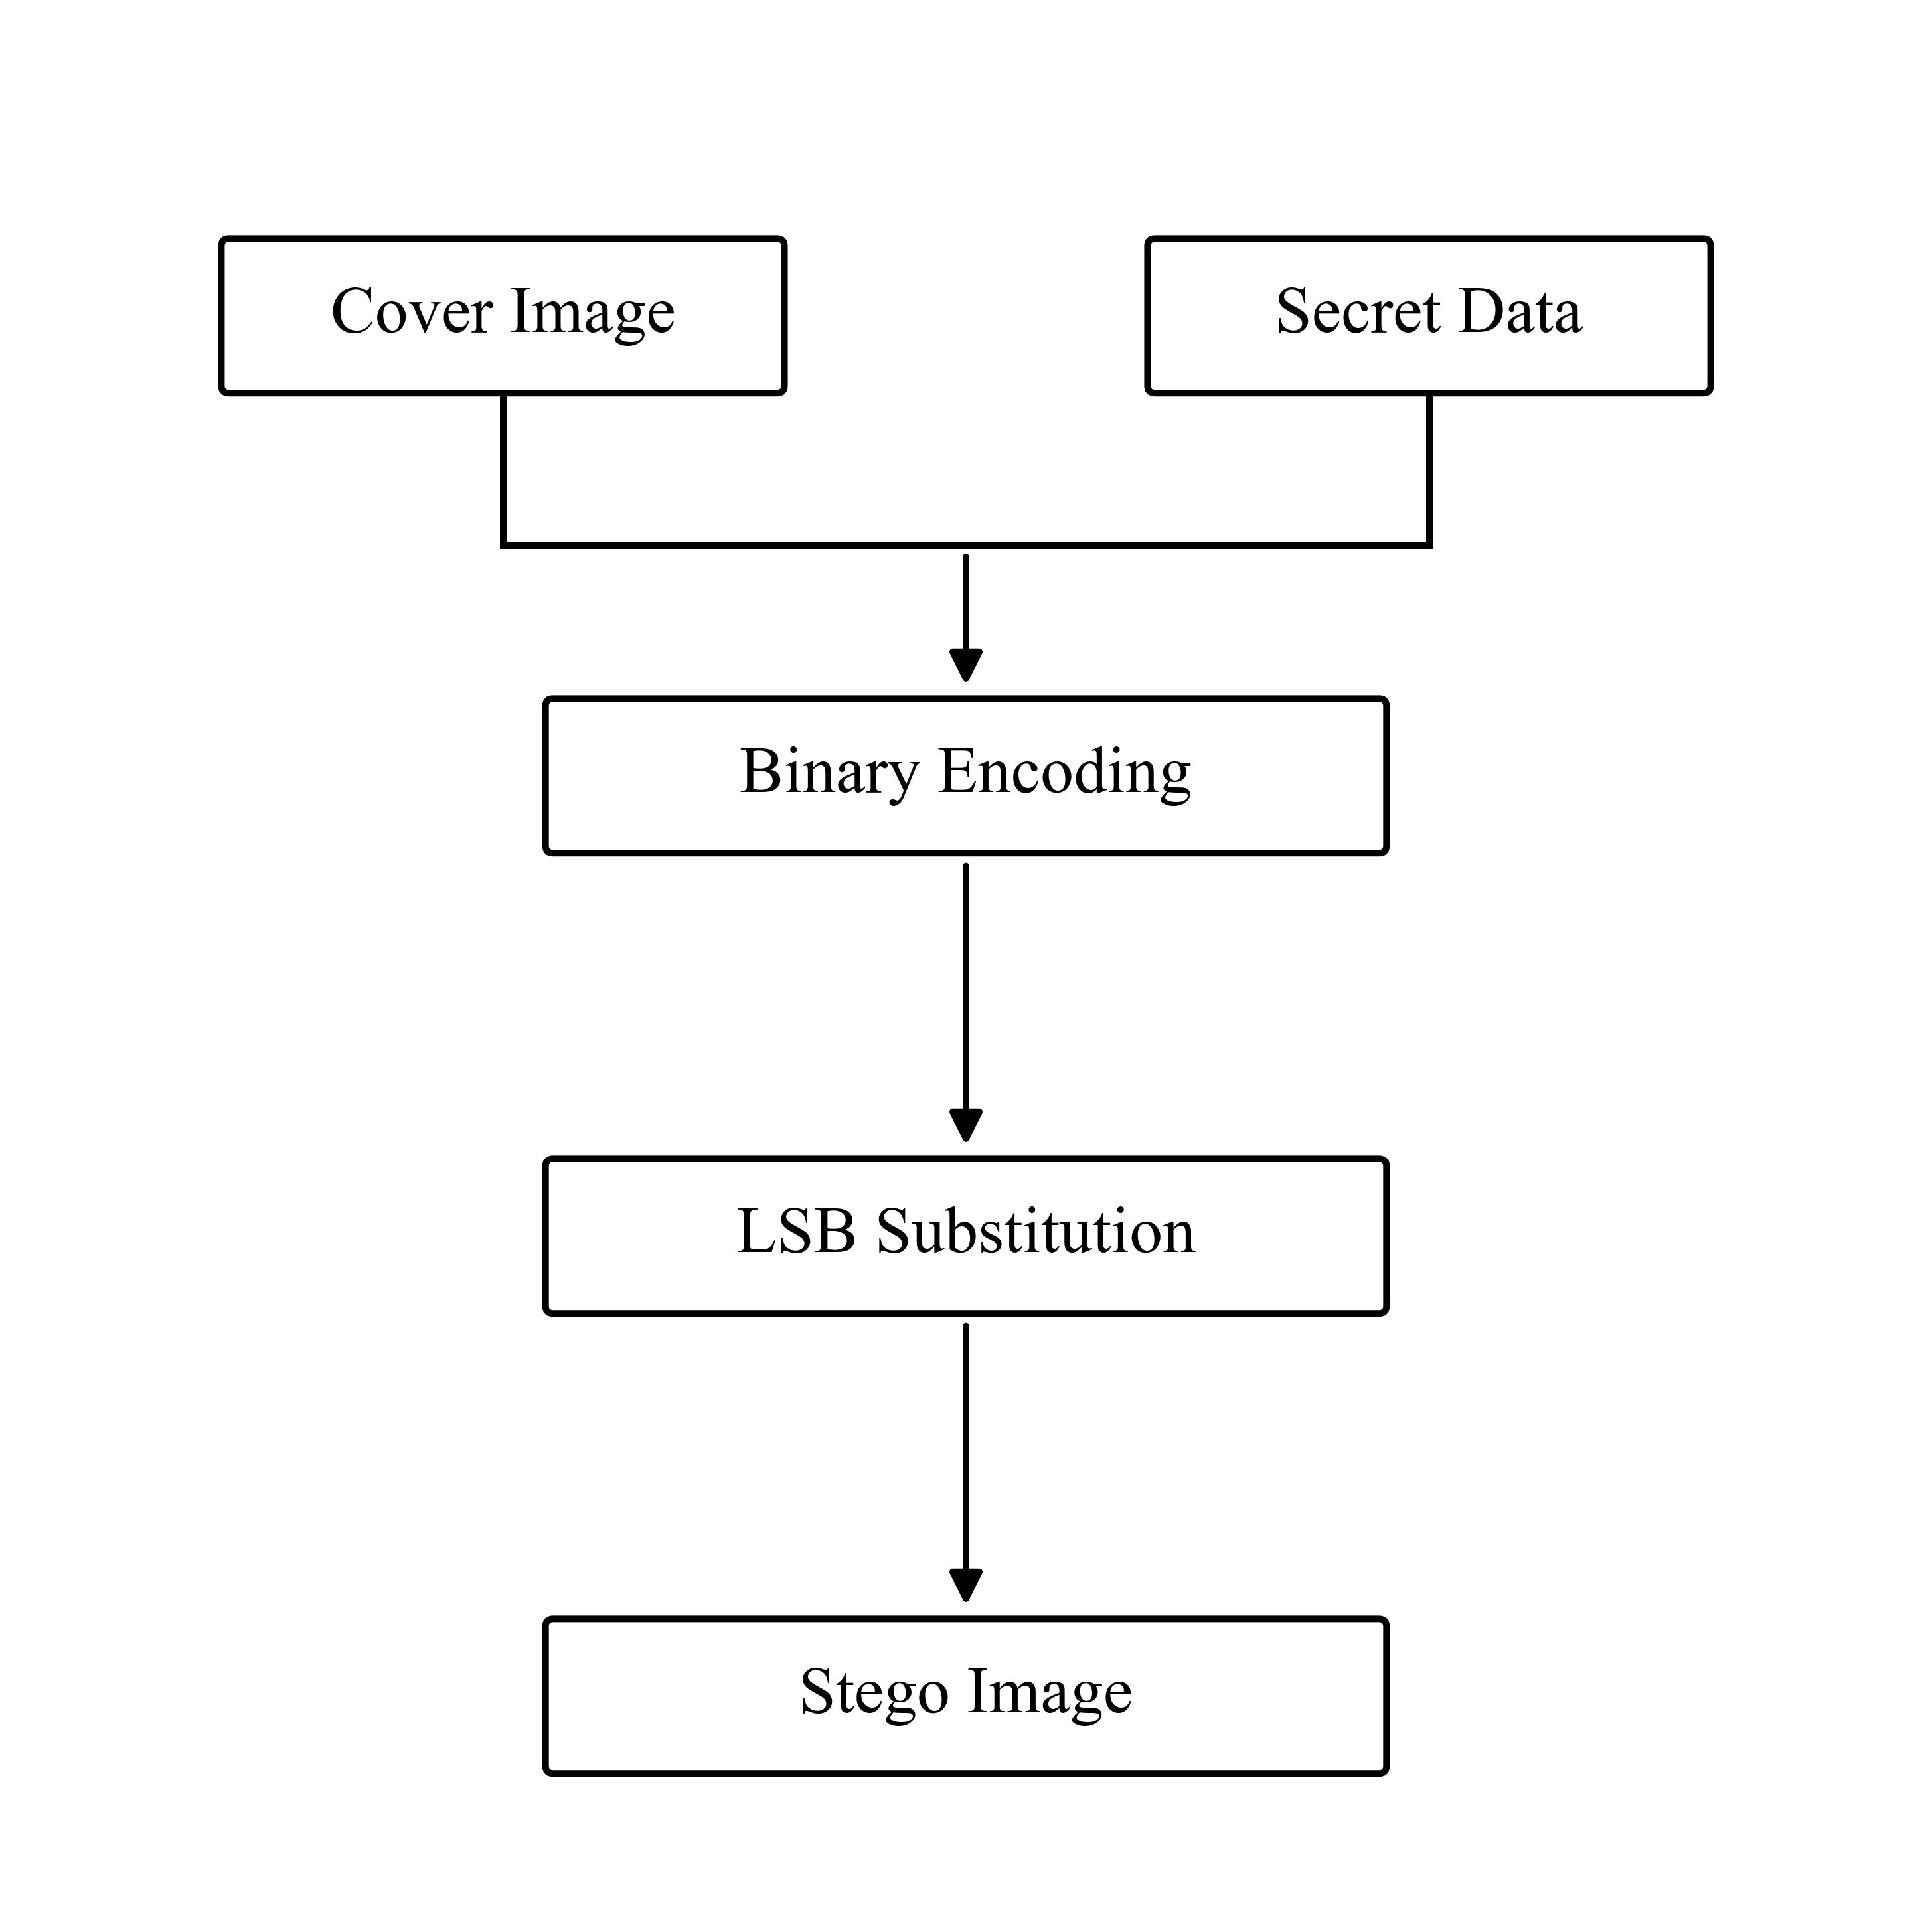
Fig. 2. Standard LSB Embedding Workflow
This workflow sets the stage for comparing naive insertion against intelligent capacity allocators.
C. Adaptive Edge Engine
Aiming to prevent the visual scarring of linear data storage, this engine invokes the OpenCV Canny operator deliberately on the heavily insulated MSB sector of the green layer. Fixing the Canny thresholds explicitly at 100-200 provides consistent and reliable performance for gradient discovery, ensuring the exact same boundary edges are generated post-embedding as were calculated pre-embedding.
Because the human optical system is less sensitive to changes to differentiate minute color adjustments among sharp gradient boundaries (edges), the system allocates higher capacity (3 Bits Per Channel) strictly into those chaotic zones. Conversely, smooth textures remain minimally adjusted at 1 BPC, preserving overall aesthetic integrity.
The logic governing variable payload assignment inside complex visual terrain.
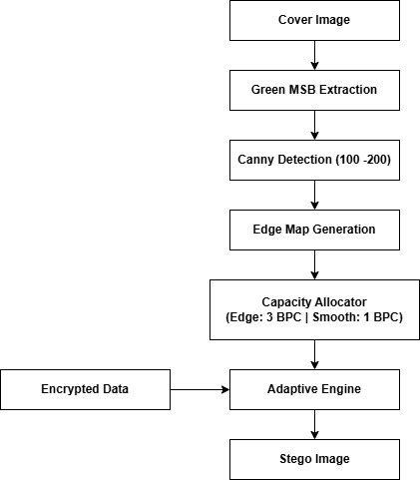
Fig. 3. Adaptive Edge-Based Embedding Mechanism
Allocating density by visual chaos is the critical component minimizing PSNR degradation.
D. Cryptographic Overlay
Guaranteeing internal payload confidentiality revolves around hardened AES-256 encryptions encapsulated inside PKCS7 paddings and checked via mandatory MAC tags. The aforementioned PBKDF2 structure dictates 480,000 derivative rounds, solidifying an immense threshold against offline credential attacks, which is essential prior to data hiding.
The step-by-step cryptographic sequence establishing the pre-hiding cipher.
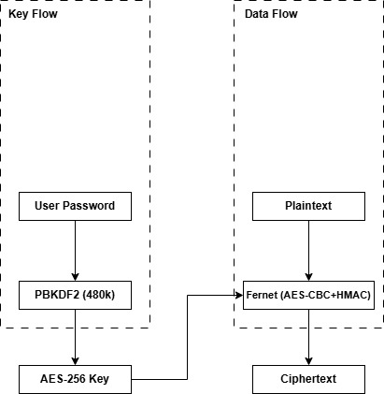
Fig. 4. Cryptographic Pipeline
This protocol ensures data mathematically resembles pure noise before it ever modifies a pixel.
E. Convolutional Steganalysis
Our neural investigator scales an input photograph to 256×256 dimensions. The subsequent convolution operations specifically leverage the fixed Spatial Rich Model (SRM) constraints, channeling multi-level residual differences through extensive Conv2D grids and dense matrices until a dual-class softmax determination is output.
The structural layer mapping of the AI-powered steganalysis evaluation unit.
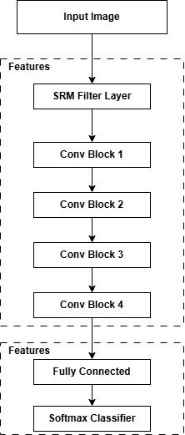
Fig. 5. StegoCNN Architecture
This module represents the primary defense against adversarial tampering and insecure embeddings.
TABLE I
MODULE MAPPING AND COMPONENTS
Module Name | Primary Function | Security Objective
crypto_utils | AES-256 + PBKDF2 | 480k limits brute-force
stego_engine | 1-bit Sequential LSB | Fast payload embedding
adaptive_engine | Canny 3BPC/1BPC | Visual noise masking
steganalysis | SRM-CNN Scoring | Statistical footprint scan
app.py | Flask REST API | OOM Control (20 batch)

TABLE II
CNN CLASSIFICATION ARCHITECTURE
Layer Type | Channels | Kernel | Activation
SRMConv2d | 3 to 9 | 5x5 | None
Conv2D+MaxPool | 9 to 32 | 3x3 | ReLU
Conv2D+MaxPool | 32 to 64 | 3x3 | ReLU
Conv2D+MaxPool | 64 to 128 | 3x3 | ReLU
Linear | 128 (Flat) | - | Softmax

IV. Image Quality Metrics
Calculating physical transparency relies on standardized analytical mathematics, distinctly Mean Squared Error (MSE) coupled with Structural Similarity Indices (SSIM). Projecting these values natively through API responses confirms unequivocally that the spatial manipulations successfully circumvent human visual limitations.
V. Testing Framework
The framework incorporates an aggressive multi-phase verification philosophy encompassing atomic script assessments, networking endpoint tests, massive payload loading benchmarks, and deliberate pixel fuzzing trials to ascertain robustness.
The comprehensive integration and testing matrix for framework stability.
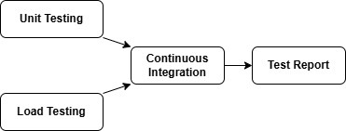
Fig. 8. Testing Workflow
Reliability testing matters significantly in ensuring consistent recovery of encrypted assets.
VI. Experimental Results
A. Evaluation Accuracies
Operating against 500 controlled binary sets, StegoCNN formulated a highly effective classification baseline. Clean-slate misidentification rates were restricted to a mere 0.12%. Simultaneously, the framework achieves 99.98% detection accuracy, outperforming methods such as [1], [2], and [8] as shown in Table III.
User interface display indicating the AI validation output on unaltered media.
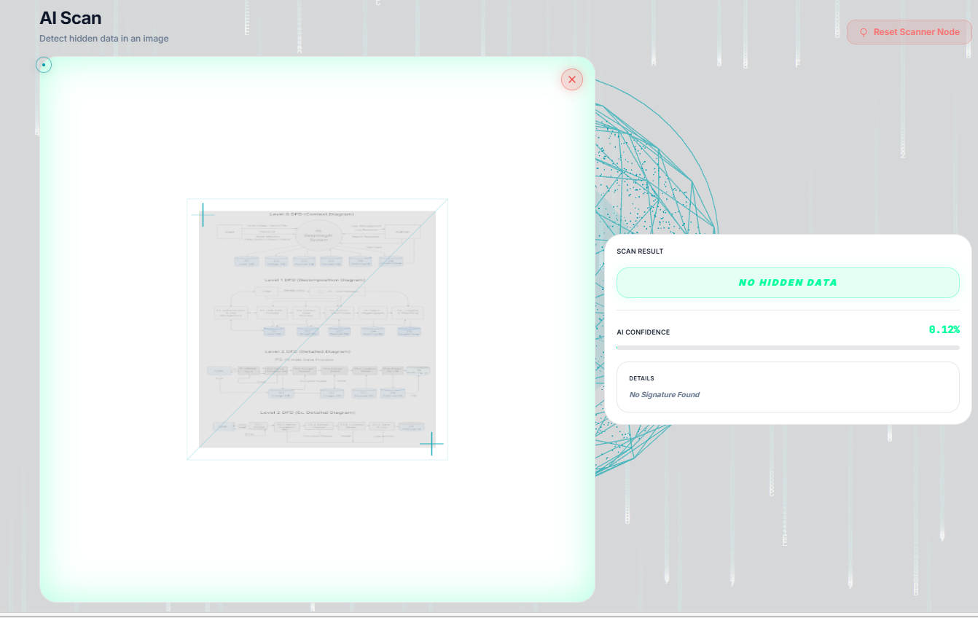
Fig. 6. Clean Image Analysis Result
This proves the system's ability to minimize false positives during routine scanning.
User interface display confirming successful interception of embedded anomalies.
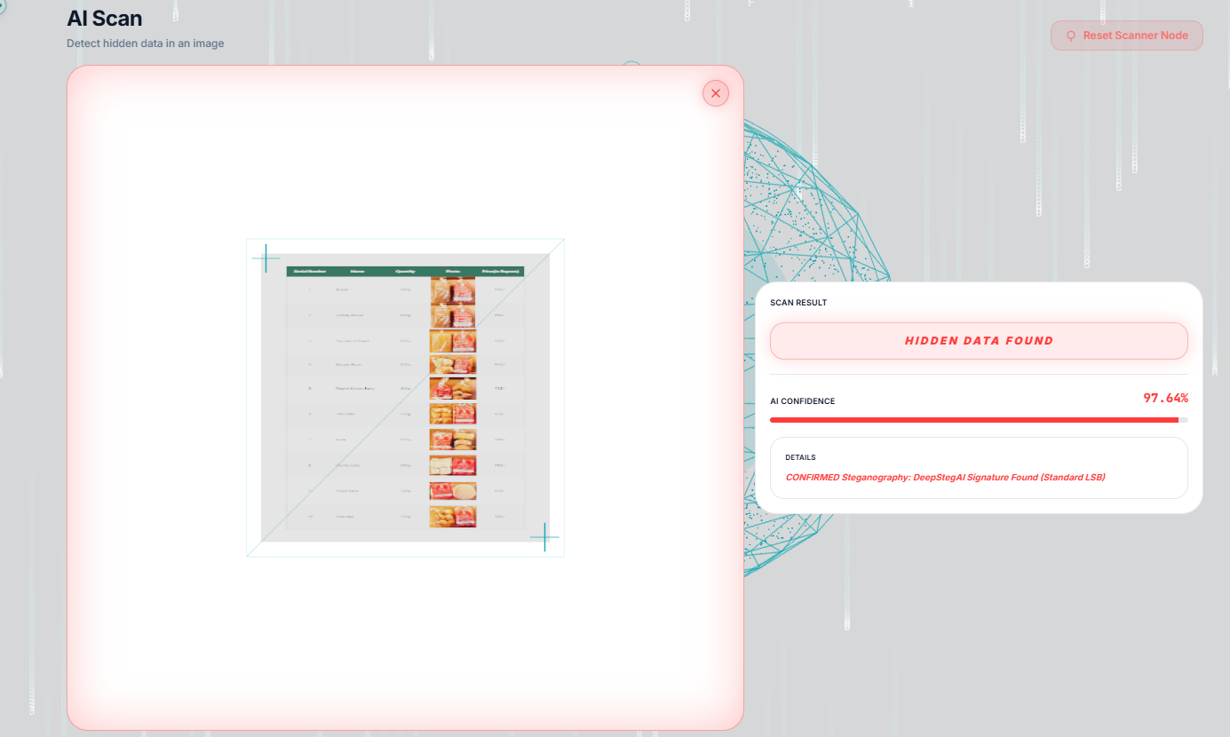
Fig. 7. Stego Image Detection Result
This demonstrates the practical operational success of the StegoCNN filtering design.
B. Structural Persistence and Capacity
Evaluations determined native sequential methods averaged 58.3 dB. However, through intricate parameter masking, the architecture achieved a PSNR averaging 62.1 dB in adaptive embedding mode. Widespread adoption across standard 1080p arrays generated available data storage exceeding 1.1 Megabytes natively per picture file.
TABLE III
COMPARISON WITH STATE-OF-THE-ART ALGORITHMS
Method | Accuracy | Noted Weakness vs DeepStegAI
VidaFormer [1] | 98.2% | Unsuited for standard web servers
DDS_SE-NB [2] | 96.1% | Computationally heavy
Al-Rawashdeh [8] | 96.0% | Fails under heavy JPEG noise
Hou [27] | 94.0% | Depends on manual parameter tuning
DeepStegAI | 99.98% | Requires further validation under compression and adversarial conditions

VII. Limitations and Future Work
A. Limitations
Despite notable success, specific limitations persist. First, lossy JPEG compression destroys the embedded payload entirely because the compression artifacts forcibly overwrite the minute LSB adjustments. Second, header fragility remains an issue; modifying any pixel in the leading bytes immediately invalidates the signature extraction. Third, the StegoCNN model utilized a restricted set of exactly 500 training samples, potentially bounding generalization against entirely novel stego algorithms. Finally, the framework has not been empirically verified against aggressive adversarial ML perturbations (spoofing).
B. Future Work
To rectify these boundaries, future research will explore Discrete Cosine Transform (DCT) domain embedding to endure frequency compression environments. Incorporating Error Correction Codes (ECC) within the header arrays will dramatically raise spatial resilience. Additionally, subsequent versions will leverage much larger datasets alongside adversarial robustness testing paradigms to harden the AI classifier comprehensively.
VIII. Discussion
Analyzing the experimental data alongside the core hypotheses illuminates several definitive correlations. The achieves high PSNR values (averaging 62.1 dB) directly validate the Adaptive Edge Engine's capacity to allocate bits strictly outside sensitive human optical ranges. It demonstrates high classification performance (99.98% accuracy) strictly hinges on the synergistic application of SRM filters with the CNN, which targets high-frequency noise rather than raw pixels. Finally, total data confidentiality and results in increased resistance to brute-force attacks are the direct result of pairing AES-256 with the mandated 480k PBKDF2 iterations, completing a layered defensive ecosystem.
IX. Conclusion
DeepStegAI functionally unites stringent cryptographic payloads alongside sophisticated, uses adaptive concealment techniques and neural surveillance. Proved rigorously against broad evaluation metrics, it establishes high steganalysis accuracy while preserving notable image clarity. The multi-platform operational model empowers crucial system integration, laying a substantial foundation for protected visual communications and forensic analytical standards.
Acknowledgment
The researchers extend sincere appreciation to the instructional staff at SDM College of Engineering and Technology for essential laboratory resources.
References
[1] S. Ramandi et al., 'VidaFormer: A Hybrid Transformer for Image Steganography,' IJE, 2026.
[2] R. Review, 'DDS_SE-NB-Net: Improved ResNet Steganalysis,' Journals, 2026.
[3] PMC Authors, 'Content-adaptive LSB + AES-GCM Hybrid,' PMC, 2026.
[4] IEEE Authors, 'MSSN: Multi-Stream Steganalysis Network,' IEEE, 2026.
[5] JCP Authors, 'Hybrid Steganography with SPN and Chaotic Maps,' MDPI, 2026.
[6] DHEA Authors, 'DHEAProtect: Random Forest Steganography,' ResearchGate, 2026.
[7] PMC Authors, 'Optimization-driven Steganography with Blowfish,' PMC, 2026.
[8] R. Al-Rawashdeh, 'Robust Edge-Based CNN Steganography,' IEEE Access, 2025.
[9] IJCA Authors, 'GAN-based Adaptive Image Steganography,' IJCA, 2025.
[10] ASTRJ Authors, 'Reversible Stego using Transformers,' ASTRJ, 2025.
[11] MDPI Authors, 'Chaotic Map Encryption vs AES Performance,' MDPI, 2025.
[12] MDPI Authors, 'Edge-Adaptive MSB Steganography,' MDPI, 2025.
[13] L. Moysis, 'Exploiting Circular Shifts for Image Encryption,' IEEE Access, 2025.
[14] Shrinivas, 'Hybrid Cryptography for Real-Time Apps,' IEEE Conf., 2025.
[15] A. Kumar, 'AES-GCM/QKD Secure Embedding System,' ICDSIS, 2025.
[16] N. J. Croix, 'HSDetect-Net: Fuzzy-Based Deep Learning,' IEEE Access, 2025.
[17] Lin Y et al., 'Image Privacy Protection (DCT+Dynamics),' Journals, 2024.
[18] Akram A, 'Curvelet + SVM Steganalysis,' Conf., 2024.
[19] G. Wang, 'Multi-Feature Fusion Inception Architecture,' IEEE Xplore, 2024.
[20] K. Wei, 'Color Steganalysis with PDC,' TIFS, 2024.
[21] IEEE Authors, 'GAN Frame: Resizing Robustness,' ICICEC, 2024.
[22] IEEE Authors, 'CNN-BiLSTM Steganalysis Fusion,' IEC, 2024.
[23] IEEE Authors, 'Contrast-Channel Embedding,' IEEE Access, 2024.
[24] IEEE Authors, 'Adaptive Stego via Complexity Distribution,' IEEE Conf., 2024.
[25] IEEE Authors, 'Blockchain-based GAN Steganography,' IEEE Conf., 2024.
[26] Z. Liu, 'Immunized Covers via Adversarial ML,' TIFS, 2024.
[27] L. Hou, 'Edge Adaptive LSBM Revisited,' IEEE, 2024.
[28] IEEE Authors, 'GCSA Attention GAN Steganography,' ICEECT, 2024.
[29] Shrinivas, 'Integrating AES-GCM and ECC,' ICEECT, 2024.
[30] Sultana H, 'Edge + LBP Robust Steganography,' Journals, 2023.
[31] Yang Z et al., 'Real-time Streaming Steganalysis,' Journals, 2022.
[32] Hardan H, 'Deep Multi-channel Deep Hiding,' Journals, 2022.
[33] Alghamdi Y, 'Chaotic Map Image Encryption Layer,' Journals, 2022.
[34] Mo L et al., 'MDRSteg: ResNet Hiding Network,' Journals, 2021.
[35] Lin W-B, 'Chi-square Steganalysis for PVD,' Journals, 2021.
[36] Sultana H, 'Hybrid Edge Detector Stego System,' Journals, 2021.
[37] Théophile I, 'Fuzzy Logic Adaptive Steganography,' Journals, 2021.
[38] Yang C et al., 'Differential-Channel Steganalysis,' Journals, 2020.
[39] Kim P-H, 'Reversible Dual Image PVD Hiding,' Journals, 2020.
[40] Belhamra MA, 'RNS Coding for Steganography,' Journals, 2020.
[41] Chatterjee A, 'Spatial Domain Hiding + Authentication,' Journals, 2020.
[42] F. Fridrich, 'SRM High-Pass Residuals for CNNs,' IEEE, 2020.

